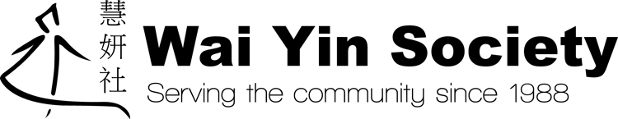

通告
慧妍社將於二零一八年三月三十日（星期五）及四月二日（星期一）復活節假期休息。
我們會於二零一八年四月三日（星期二）恢復正常服務。

Office Closed Notice
Wai Yin Society will be closed on Good Friday 30th March, 2018 and Easter Monday 2nd April, 2018.
Service will resume on Tuesday 3rd April, 2018.
Thank you very much!

